ACSL

American Computer Science League
TEST INSTRUCTIONS

- MATERIALS ALLOWED: Plain paper and pencils (no calculators, headphones or any type of electronic device)

- SCORE SHEETS:
Use pencils only to mark the answers.
Put your name, school name, grade and division on the back of the scoresheet.
No erasures are allowed – use an additional score sheet if necessary.
There will be no appeals based upon answer sheet errors.
Answer E is for none of the above – we guarantee at least 1 answer E.

- STUDENT PROCEDURES:
Keep your eyes on your own paper.
Keep answer sheets and scrap paper guarded.
You must stay in the room until the end of the test.
You can keep all materials at the end.
The time limit is 45 in the Junior Division and 60 minutes in all other divisions.

- TEST ANSWERS
Proctors will read the letter answers at the end of the testing period.
Appeals in writing must be brought to the scoring room no later than 3:30 PM. The appeal must show your detailed solution.

ACSL
American Computer Science League
2013 - 2014

All-Star

Short Round Questions
A. 0
B. 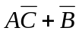
C. 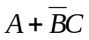
D. 1
E. None of the above

- Boolean Algebra
Simplify the following Boolean expression:

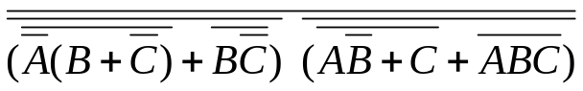

2. Digital Electronics
Let € be a gate with 3 inputs that is true if exactly 2 inputs are the
same. Let ◊ be a gate with 3 inputs that is true if at least 1 input is
true. How many ordered quadruples make the following circuit true?

A. 0
B. 2
C. 4
D. 8
E. None of the above

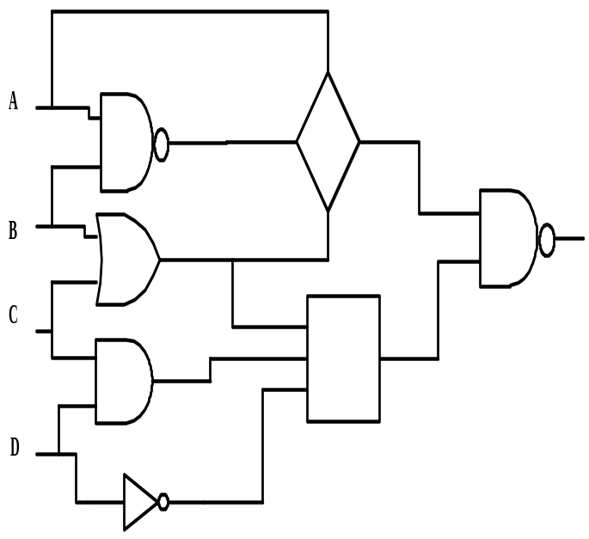

3. Prefix-Infix-Postfix
Define: a # b = (a+b)/2
a % b = [a/b] = greatest integer ≤ a/b
a& = √a = principal square root of a
Evaluate the following prefix expression: (all single digits)

- + % 9 2 * & 9 ↑ + / # 9 7 4 & 4 2 / / * / * 9 # 7 5 % 7 2 8 & + 9 7 & 4

A. 21
B. 52
C. 34
D. 56
E. None of the above

- Computer Number Systems
Which term is next (expressed in octal) in the sequence below?

11₂ 11₈ 11011₂ 51₁₆ ?₈

A. 213
B. 243
C. 323
D. 363
E. None of the above

A. 11010, 10010
B. 10101, 10001
C. 11000, 00000
D. 10100, 11100
E. None of the above
5. Bit-String Flicking
Which value(s) of X (five bits long) solve the following equation?

( LCIRC – 2 ( 01011 OR X ) ) AND ( RSHIFT – 2 ( 10111 AND X ) ) = ( RCIRC – 2 ( LSHIFT – 1 X ) )

- What Does This Program Do?
What is the output after this program is executed?
c = 99
for i = 2 to 99 step 2
c = c - 1
next i
for j = 3 to 99 step 6
if j/5 = int(j/5) then c = c – 1
next j
for k = 5 to 99 step 10
if k = 5 then c = c – 1
if (k/3 <> int(k/3)) and (k<>5) then c = c – 1
next k
print c
end

A. 36
B. 39
C. 41
D. 49
E. None of the above

5. Bit String Flicking
How many values of X (five bits long) solve the following
equation?

- Recursive Functions
Find(13,1)given: 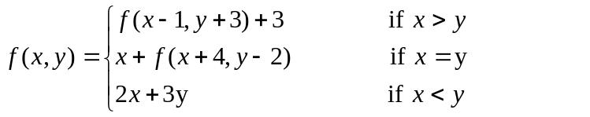

A. 75
B. 91
C. 88
D. 94
E. None of the above

- Data Structures
Given a heap of depth six and with the bottom level completely filled, what is its internal path length?

A. 384
B. 642
C. 896
D. 1538
E. None of the above

9. Graph Theory
Adding which directed edge to the original
graph will increase the number of cycles
from A by the smallest number?

A. EB
B. EA
C. EC
D. ED
E. BA
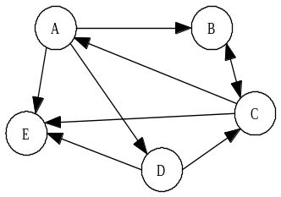

- LISP
(SETQ X ’( 1( 2 ( 3 4 ) ) ( 5 ( 6 7 ) 8 ( 9 ( 1 4) ) ) ) )

Evaluate the following expression:

( CAR ( CAR ( REVERSE ( CDR ( CDR X) ) ) ) )

A. ( 6 7 )
B. ( 5 )
C. ( 5 ( 6 7 ) )
D. ( 1 4 )
E. None of the above

- FSA and Regular Expressions
Which of the strings below are represented by the following FSA?
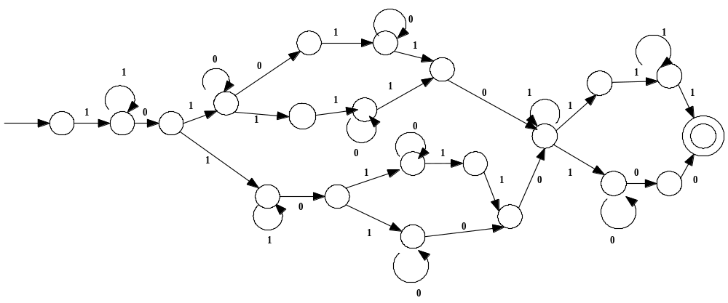

+

a) 0001101001 b) 01110001011 c) 010101010
d) 0100000 e) 011001011 f) 01010010

A. a, b, c, d
B. a, c, d, e
C. a, c, e, f
D. a, c, d, f
E. None of the above

- 1010100111 d. 1101101011011100
- 11010110100101 e. 1010100011010
- 101001100101111111 f. 11010001000101111000000000

- Assembly Language
After the following program is executed, what is
printed? The data for the program is 1, -1, 2, -2, 3, -3, 4, -4, 5, -5, 0.
TOP READ N SUB =30
BE DONE BE ANS
LOAD N BU TOP
MULT N ANS PRINT N
MULT =2 BU TOP
STORE TEMP1 DONE END
LOAD N
MULT =4
STORE TEMP2
LOAD TEMP1
SUB TEMP2

A. 1296
B. 3025
C. 2025
D. 4356
E. None of the above

- 5, -1
- -3, 2
- -3, 5
- 4, 5
- None of the above

